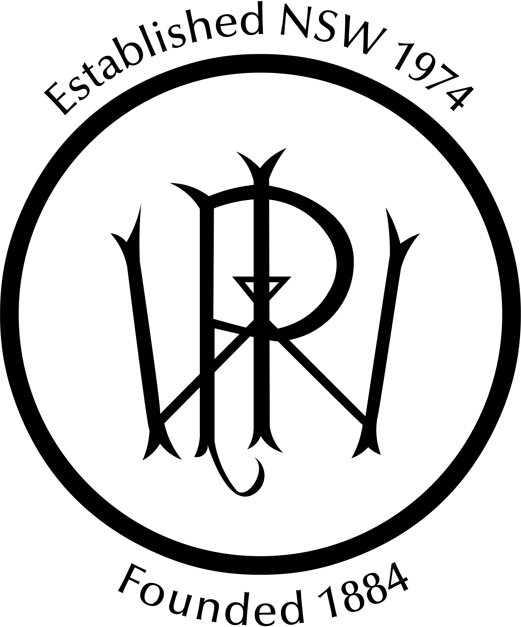
Permanent Way Institution Inc
KE N E RI CKS ON
IN N O V A T IO N AW ARD

JUDGES

Gareth Beynon, LINK Rail and Civil

Raquel Rubalcaba, TfNSW

Sunail Hasnain, Sydney Trains

Ken Erickson was elected as a Fellow of the New South Wales Permanent Way Institution on 30 November 1981. He was a member of the Committee from 1981 until his untimely death on 25 November 1988. In his 7 years on the Committee he was an Editor, with wry humour and then Secretary, with sparkling wit.

Ken was a dynamic member of the committee and a gifted speaker. His "summing up" of our only conference at Kings Cross will always be remembered by those lucky enough to be present.

Ken was always trying to provide new ideas or concepts to the PWI, hence it is fitting that this Achievement Award, which particularly looks for new ideas, is named in his honour.

This Annual Innovation Award has been incorporated in the PWI Awards to recognise an initiative or significant advance in rail technology which has promoted improvement in any part of the Rail Industry during the last year. The Award recognises the contribution of a business or individual who has implemented a novel approach, strategy, or tool that has improved outcomes in the rail industry. Successful applicants are not necessarily required to have generated a new product, rather, this award equally considers the use of current technologies and approaches in new ways to solve problems within the Rail Industry.

The field is open to all relevant disciplines within the rail industry, this could include perway, stations, systems, management, design, electrical and signalling. Eligible entries may focus on areas such as design, componentry, techniques, construction, maintenance, mechanisation, or automation.

Entries must have been completed in the last financial year by, or under control of, a member of the NSW Section, whether on a government or private railway system.

Judging is based on:

Scoring Category Available Score
Difficulties overcome | 10
Contribution / Impact to Rail | 20
Technical Input | 20
Degree of innovation in Rail aspects | 20
Contribution to Safety | 10
Systems Assurance | 10
Commercial benefits | 10
Total Score/Marks: | 100

Ken Erickson Innovation Award

